Hello Nishit in addition to #11444, we have spoken to the site admin regarding our confusion with APIs and here is what they suggest:

If it is inventory numbers the data should come from Telinta API but their settings come from vendors API. If it is Activated Numbers then API should be from Telinta API.

Some Comments below:
- In inventory numbers please set minimum 4 digits for customers Pin Conde input. If customers add 3 digits pin number please let the message tell them something like: - “Pin Code can not be less than 4 digits”.
- See screen shot below some numbers settings look correct (screen shot “A” below)

Screen shot A
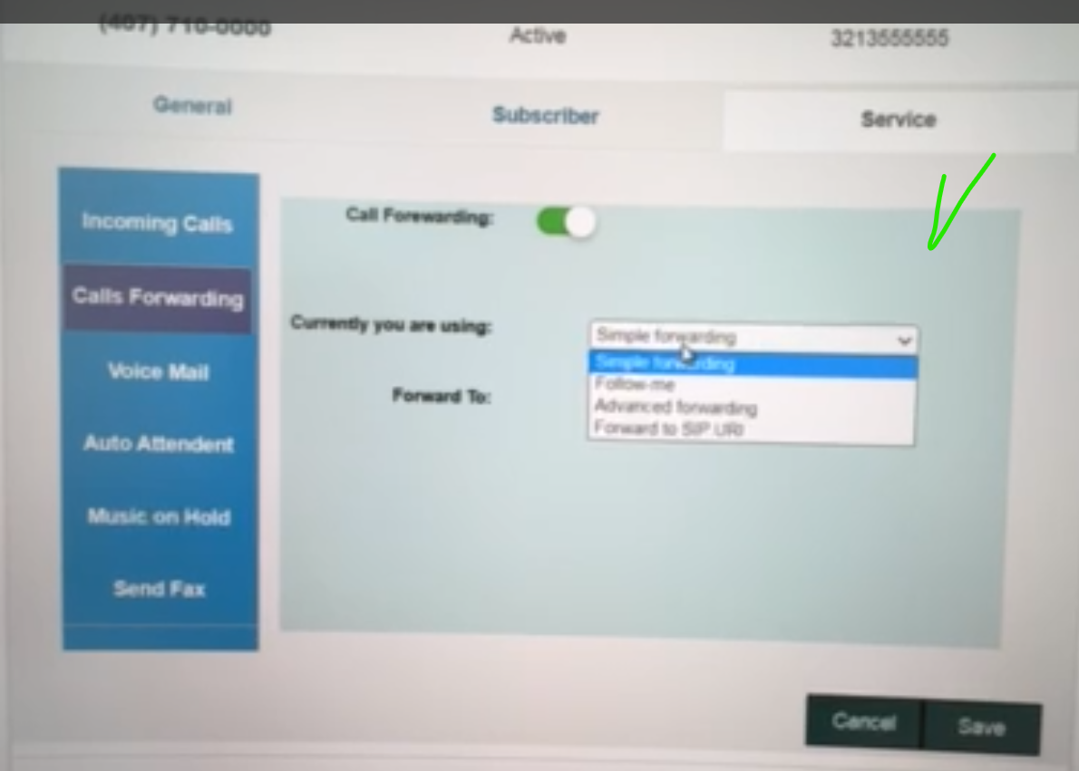

Some number’s settings are incorrect please see next screen shot B below. Please note on screen shot B - Currently you are using filed drop down does not work and tab display information that supposed to be only shown when customer select “Follow Me” Option from the Currently you are using filed. Please fix it

Screen shot B
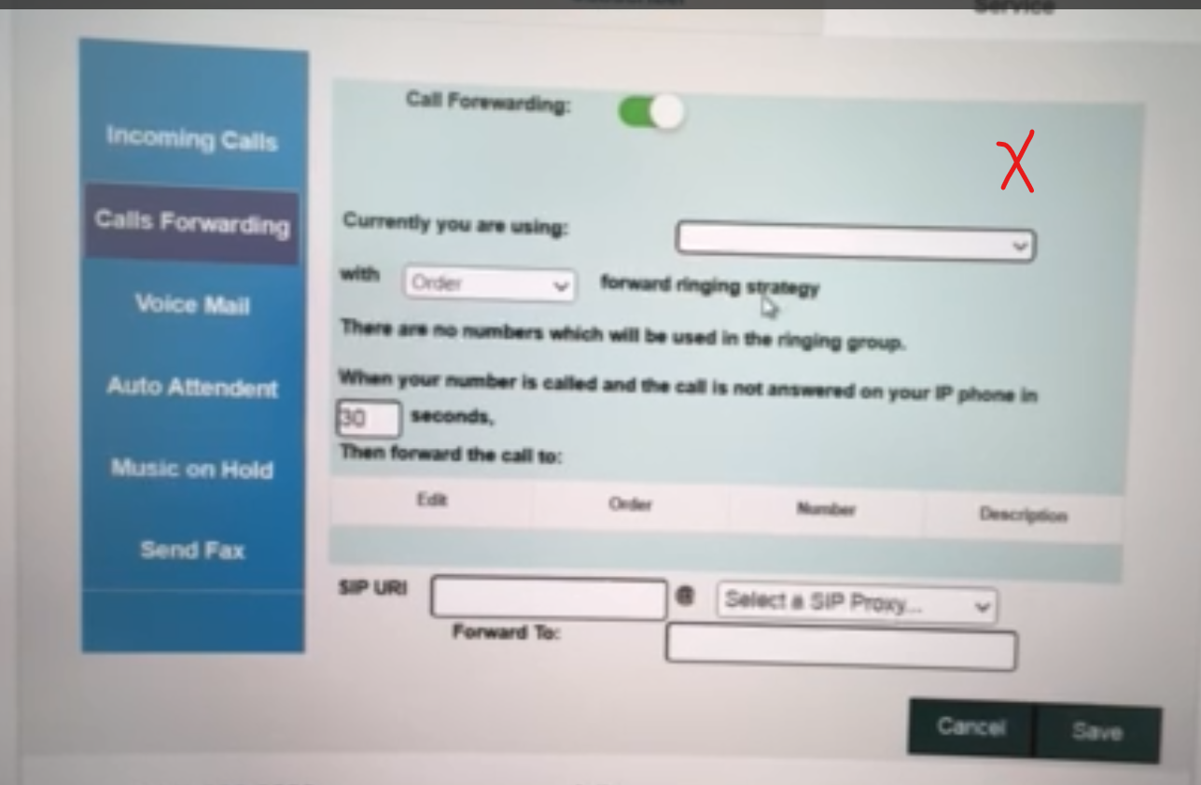
- We tried to put a call forwarding on active numbers and it does not work we could not save call forwarding number as it does not work please fix it.

Our finance team advised to add more funds to this job for you as we sending some additional tasks to Custom Features developments phase. So please find your office page updated today.

Cheers

